Name: _______________________ Date: ______________________ 4.3 VOLCAOES
REVIEW: What’s the difference between magma and lava?

How a volcano ______________ (will it explode? Will it ooze?) is based for the most part on_________________________.
- What is viscosity?
  - Viscosity is how ____________________ a substance is to _______________________. For example, honey is more viscous than water.
  - Magma that contains more _____________________ will be more viscous, magma that contains less silica will be _______________ viscous.
  - Magma that is very viscous will __________________, magma that is less viscous will ________________.
  - Lava that is __________________ will be less viscous (like if you heat up honey) and will _____________ more.
  - Lava contains ________________________________, and if the lava is very viscous, those bubbles cannot __________________. Instead, the bubbles will _________________________ upwards.
Along with lava, volcanoes also eject ________________________________________, which is a fancy name for particles. They can be as small as ________________ or as large as _____________________.

There are 3 main types of volcanoes, but they all have this general form:
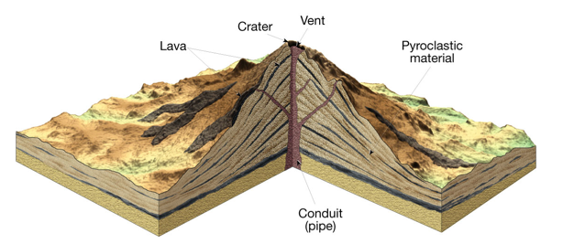

Volcano Type | Description
1. Shield | Made of very ______________ lava that spread really far and hardened.  _____________________ shape  Lots of ______________________ volcanoes (for example, Hawaii)  Eruptions are not very __________________________
2. Cinder cone | Ejects lots of ______________________ (chunks of pyroclastic material) that accumulate at the bottom.  _______________________ sides  ___________________________ (usually only erupt once).  Usually pretty ___________________
3. Composite cone | _________________!  Produce both ______________ and ___________________ material that can reach up to ______________ mph!  Usually found in the __________________________, which is a zone of volcanoes that circles the Pacific Ocean.  Can sometimes form ____________________, which are mudflows that are made when lava mixes with ________________ and ___________________.

Other, minor types of volcanoes:
__________________________ are volcanic depressions that are created when the ______________________________ is drained and the volcano _____________________ in on itself. Instead of looking like a mountain, it looks like a __________________________.

Volcanic ____________________ are formed when a volcano has been _____________________ so that only the magma _______________________ (pipe) is left.

____________________________________ are made from very low-viscosity lava flowing out of a ____________________ (crack) in the ground. The lava spreads really far and creates a ______________________ landform.
Name: _______________________ Date: ______________________

VOLCAAAAAANOES!
Directions: Answer the following questions in full sentences.
- What kind of volcano produces the most violent type of activity?

- The viscosity of magma is dependent upon what?

- What is pyroclastic material?

- What is a caldera?

- How is a volcanic neck formed? Why are some volcanic necks very economically important?

- What is the Ring of Fire? What kinds of volcanoes are found there?

- What is viscosity? How does it affect volcanic eruptions?

- Match the following terms with the appropriate descriptions:
- Shield ________

- Cinder cone ________

- Composite cone ________

- Caldera ________

- Viscosity ________

- Lava plateau ________

- Large volcanoes that produce violent eruptions
- A large, flat volcano made from slow-moving lava
- Low, broad volcanoes that form islands
- A volcano that has collapsed, forming a crater
- Small volcanoes with short life spans
- A substance’s resistance to flow

