Name: ____________________________________________ Date: ___________ 4.5 Earthquake Waves & Destruction
Wave | Relative Speed | Movement | Where | Amount of damage
P Wave
S wave

Surface Wave
1.What is a seismograph?
Real Life Application:
What is the interval in minutes between the start of the first P wave and the start of the first S wave?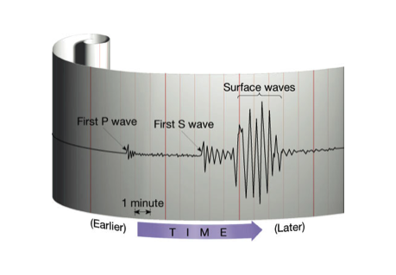

2. What information does a seismograph give us?

3. How do we get this information?

4. What is a seismogram?

5. What is the Richter Scale?

Can you read this graph?
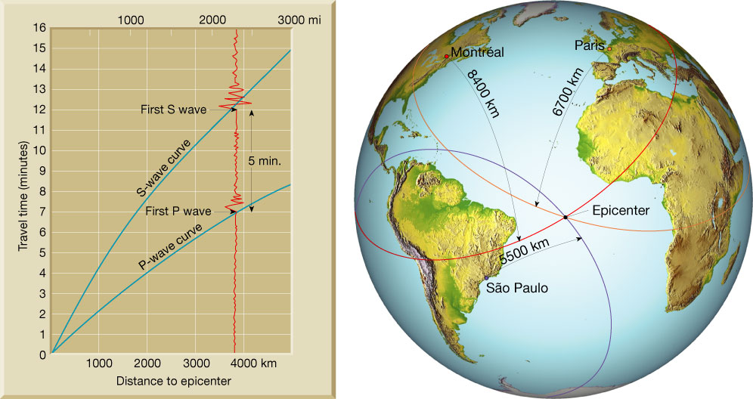
If a station records 2 minutes elapsed time between the arrival of the first P wave and the arrival of the first S wave, how far in kilometers is that station from the epicenter?
Earthquake Destruction:
-Fires: What causes fires? ______________________________________________________________________________
-Why are they so destructive? __________________________________________________________________
**More than ______________ people died in fires alone from a 1923 earthquake in Japan.

-Tsunamis: An underwater __________________ caused by an ____________________ or underwater landslide triggered by vibrations.
Draw the boundary here:
-Where do tsunamis occur? ____________________________________
Haiti and Chile: A Tale of Two Earthquakes
“The 8.8-magnitude earthquake that hit Chile early on Feb. 27, 2010 was 500 times stronger than the 7.0 quake that killed an estimated 200,000 Haitians the previous month. And yet the number of casualties in Chile appears to be exponentially smaller, with the official death toll only in the hundreds. Far fewer people were rendered homeless than in Haiti, and much of the telephone service in Santiago and parts of central Chile had been restored within five hours”

Why do you think there was more damage in Haiti than Chile?

Earthquake Proof Buildings
1. How many lives did the quake claim?

2. Describe the building that was “pancaked” in the Haiti quake?

3. What weakness do “cubes” have? Why is this bad for earthquakes?

4. Name the techniques engineers have found to work better against earthquakes?

5. How do we know these “life-safe” building codes work?

6. Why does Haiti not have “life-safe” building?

7. How does rapid population growth affect buildings?

8. Name a strategy to improve buildings in Haiti?

9. Can scientists predict earthquakes?

Earthquake Damage Prevention:
-Bricks and ____________________ are more brittle (__________)
-Steel, wood, and _________________________ are more flexible (_______________)
-_____________________ and rectangle hold up more than L, U, T, H, or O shaped-buildings

