Name: _____________________________________ 5.4 Human Impact - Independent Practice
1. List as many advantages YOU have by living in an urban area (minimum of three - 3).

2. Now list at least five (5) negative effects urbanization has caused on the environment.

3. List three (3) resources that would be compromised (used up) due to human overpopulation?

4. How is coal and oil formed differently? Compare and contrast the differences and similarities in their formation.

5. We need food to live so explain why agriculture can be devastating to our environment, specifically the lithosphere.
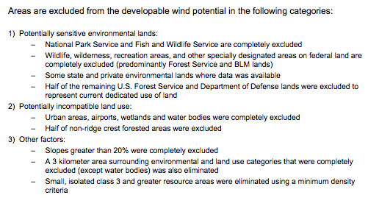

6. Read the information in the box below. Wind power could be a solution to our energy crisis and help reduce our addiction to oil. Name three (3) surprising challenges when it comes to wind power.

7. Using the image below, compare and contrast nuclear energy production (fission) to that of the sun’s fusion. How are they different, and how are they similar?
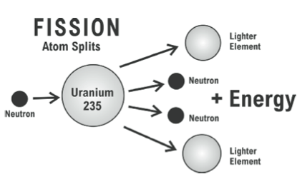

8. Once again our impact on the environment, specifically the lithosphere, connects back to information on erosion. Name three (3) ways to reduce soil erosion.

9. In five (5) complete sentences write a letter to our local congress representative persuading them to invest money and our future in a renewable energy source of your choice.

