Name: ____________________________________________ Unit 6: Hydrosphere - Day 2

Real Life Application: Salt Water Intrusion in Louisiana
- What is the problem in this news report?

- What is the solution in this news report?

- What does this information tell you about salt-water intrusion?

Real Life Application: Cholera in Haiti
Background: Cholera is an infection in the small intestine caused by the bacterium Vibrio cholerae. The main symptoms are watery diarrhea and vomiting. Transmission occurs primarily by drinking water or eating food that has been contaminated by the feces (waste product) of an infected person, including one with no apparent symptoms.

- How much human waste is dumped in this site a day?

- What is the problem with the sewage treatment facility in Port au Prince, Haiti?

- Why are people at risk for Cholera in Port au Prince, Haiti?

- What is SOIL’s (Sustainable Organics Integrated Livelihood) solution to this sewage problem?

- At the very end of the video, why were they joking about this solution shows the circle of life?

Quick Quizzes: Checks for Understanding

Directions: Fill in the blank that fits best with the question on the board.

6. _______________________________

7. ________________________________

8. ________________________________

9. ________________________________

10. _______________________________

1. _______________________________

2. _______________________________

3. _______________________________

4. _______________________________

5. _______________________________

The Ogallala Aquifer- How Long Will the Water Last?
Directions: Read the article on textbook page 180 and answer the following questions.
- What is the region this article introduces?

- Why is this area one of the most important agricultural regions in the US?

- What is the Ogallala Formation?

- How was the Ogallala Formation geologically formed?

- Where does it get its water? Where does the water travel from?

- How did erosion affect the water’s travel path? Where does the water come from now?

- What invention in 1920 changed the way this aquifer is used today?

- How many wells are being used on this aquifer? How much land does these serve?

- Explain what it means for the Ogallala’s water table has declined?

- What is predicted to happen in the future to the southern High Plains?

Interpreting Diagrams: Aquifer on a barrier Island
Directions: Turn to textbook page ES 16 at the bottom of the page on Groundwater. Look at the diagram. Answer the question on interpreting diagrams using your new knowledge from today’s lesson.

Individual Practice:
- Create a pie graph to represent the amount of fresh water & salt water on earth.
- What layer would you find groundwater?

- If there was a flood event, what would happen to the water table? Draw two diagrams: one before and one after to draw how the water table might be affected.

- Anticipate: How can groundwater be considered a nonrenewable resource? Give an example
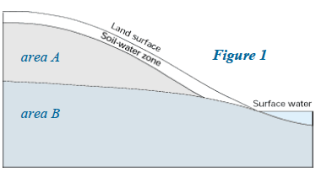

- Label the Figure 1 to the right. Where could you put a well?

