Name: ________________________________________ Date: __________ 7.2 Construct your own Climograph Assignment

Climoraphs combine temperature and precipitation data in one place. Each climate graph is made up of two major parts: a line graph displaying average monthly temperatures in degrees Celsius and a bar graph displaying monthly accumulations of precipitation in millimeters. The horizontal axis shows the time period in months. Observe the sample graph for Madras, India.
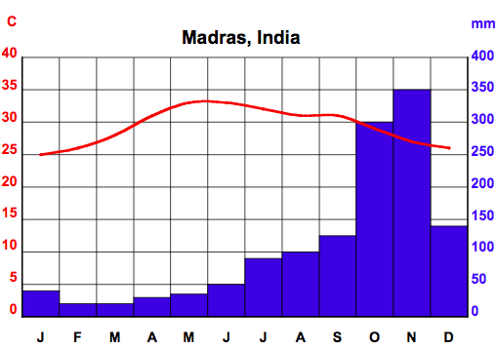

The temperature line connects a series of dots, each representing the average temperature for one month. Each column in the bar graph represents the accumulated precipitation for one month. By viewing the information together, you can quite easily determine how much the temperature and precipitation change during the year.

You will be creating two (2) climographs using Fahrenheit (°F) for temperature & inches for precipitation: one for Charlotte NC and the second will be a mystery location.

How to Construct a Climograph:
1. On a sheet of graph paper, draw the left vertical axis. This is your temperature scale. Label the units as shown in the example above. Depending on your data, you may choose to begin this scale at 40° or lower and go up to 80°F or more in increments of 5 or 10°F.
Hint: You can use two squares of graph paper for one increment to make your graph larger.

2. Now draw the right vertical axis. This is your precipitation scale. Again, label the units as shown in the example above. Start with 0 in (inches) and go up to an appropriate amount in equal and suitable increments ex 10, 20, 30...

3. Draw a horizontal line to connect the two axes at the bottom. Divide the line into twelve blocks and label each one, beginning with “J” for January.

Construct the first graph: Charlotte NC
4. Use the following information to create a climate graph for Charlotte, NC. Use the graph paper provided.
 | Jan | Feb | Mar | Apr | May | Jun | Jul | Aug | Sep | Oct | Nov | Dec
Temp (°F) | 41.7 | 43.7 | 51.1 | 60.1 | 68.7 | 75.9 | 78.6 | 77.5 | 72.1 | 61.3 | 50.9 | 43.0
Precip (in.) | 3.7 | 3.4 | 4.4 | 2.9 | 4.0 | 3.5 | 4.3 | 4.6 | 2.5 | 4.0 | 4.2 | 2.9

a. On your graph, mark a small dot in the center of the column for each month to record the average temperature. Connect the dots with a line. Use color to show this trend.
b. Now use a ruler to draw a line across the column for each month to record the accumulated amount of precipitation. Color in each bar with a color of your choosing.
c. Make sure that your climate graph has a title (i.e. Charlotte).

5. Repeat steps 1-4 using the information on temperature & precipitation on your mystery location.

Be analytical- Think about these questions as you are creating both of your climographs!
- Which are the warmest months in your mystery location and Charlotte NC?
- Which are the coldest months in your mystery location and Charlotte NC?
- Which are the wettest months in your mystery location and Charlotte NC?
- Which are the driest months in your mystery location and Charlotte NC?
- Write a sentence comparing the average yearly precipitation in your mystery location with the average yearly precipitation in Charlotte NC.

