Name: __________________________________________ 8.5 Weather Model Stations Practice

2.5.4) Predict the weather using available weather maps and data (including surface, upper atmospheric winds, satellite imagery).

Part I: Using the station models below, decode the weather conditions and record the information displayed in the following table.
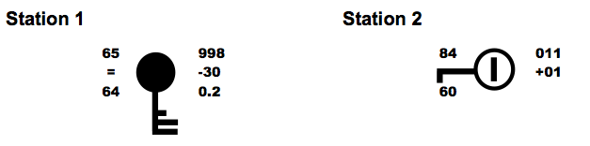

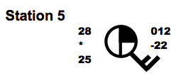

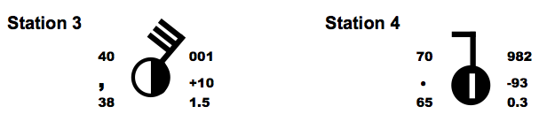

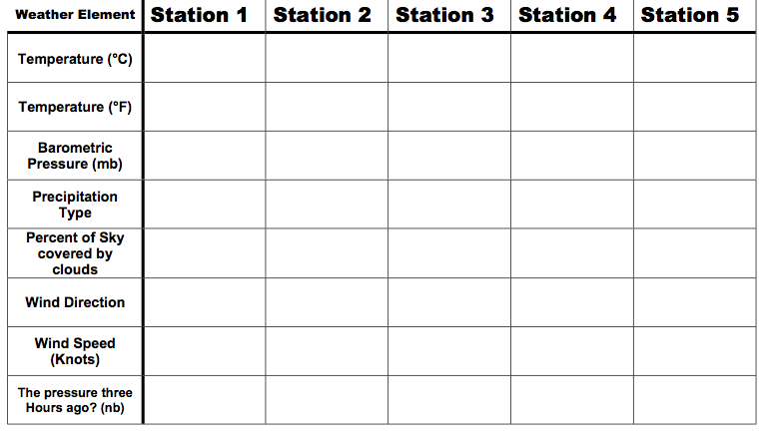
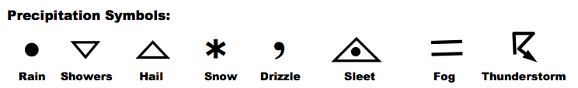

Part II: In the Chart below, you find meteorological data that was taken at several cities around the United States. Use this data to create station models for each city listed in the table on the map near the cities approximate location
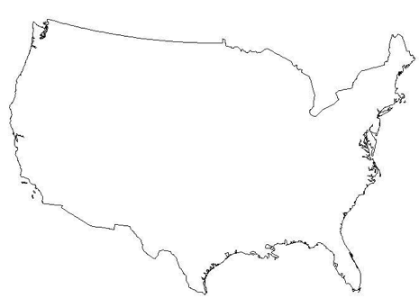
 | San Francisco CA | Charlotte NC | Seattle WA | Chicago IL | Boston MA | Miami FL
Temperature | 51 F | 47 F | 37 F | 18 F | 26 F | 81 F
Dew Point | 32 F | 16 F | 32 F | 5 F | -4 F | 66 F
Cloud Cover | 25% | 10% | 90% | 100% | 50% | 75%
Precipitation | None | Heavy Sleet | Moderate Fog | Light Snow | Light Showers | Light Thunderstorm
Wind Speed | 10mph | 5mph | 15mph | 30mph | 15mph | 20mph
Wind Direction | East | Southeast | Southeast | Southwest | Northwest | Northwest
Air Pressure | 1024.7mb | 1027.7mb | 1019.3mb | 1027.1mb | 1022.7mb | 1020.9mb
