Name: _________________________________ Date: __________________ 9.2 Population Pyramid Assignment

Part I: Answer the following questions (#1-13) according to the following population pyramids below, which represents the populations of 3 nations: one growing rapidly (Mexico), one growing slowly (United States), and one that is not growing at all (Sweden).
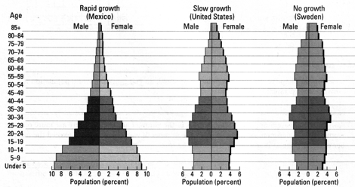

1. Which country has the greatest percentage of people over the age of 65? ___________________________________
2. What percentage of this country’s population falls into that category? ______________________________
3. Which country has the greatest percentage of people between the ages of 15-44? _________________________
4. What percentage of this country’s population falls into that category? _____________________________
5. Which country has the greatest percentage of people under the age of 19? _________________________________
6. What percentage of this country’s population falls into that category? ______________________________
7. Are there more females or males in Mexico? __________________________________________________________________
8. Are there more females or males in the United States? _______________________________________________________
9. Are there more females or males in Sweden? __________________________________________________________________
10. How did you figure out questions 7, 8 & 9? Answer in one sentence.

11. Applying Knowledge: Mexico is experiencing rapid growth. Which age group tells us this information?

12. Prediction: The percentage of elderly populations represents the quality of health care. If you had to predict, which country has the best health care? Explain why you chose this country in one sentence.

13. Applying Knowledge: Childbearing years are between ages 15-44. How can the percentage of this age group impact the population growth? Answer this question in one sentence.

