Name: ______________________________________ Due Date: __________________ Unit 6 Study Guide- Hydrosphere
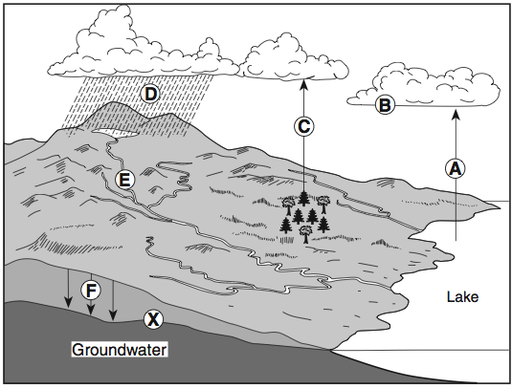
- Label the diagram on the right using water cycle vocabulary

X.

- Describe the difference between evaporation and transpiration.

- Groundwater has been seeping through cracks and openings in the limestone bedrock of this area, producing caves. Explain how this contributes to sinkholes. Refer to textbook page 178-179 for help.

- Define the following terms:
Impermeable layer | Unconfined aquifer | Confined aquifer

- Explain why unconfined aquifers are susceptible to more pollution than confined aquifers.

- Define the following terms:
Zone of Aeration | Water Table | Zone of Saturation

- Explain the process water follows as it falls as precipitation, infiltrates and becomes groundwater.

- Sketch a picture to help you remember the difference between saturation & aeration.

- If water is removed from a well faster than the aquifer can be recharged, what will happen to the water table near the well?

- If there is a lot of precipitation the zone of aeration becomes smaller so what happens to the size of the zone of saturation and the level of the water table? Why?

- Describe “Aquifer Depletion,” and name one human use of water that may be causing this depletion.

- Run-off is the biggest contributor to water pollution for North Carolina. In your own words, explain why run-off is non-point source pollution.

- Explain how run-off and rivers make it difficult to keep those accountable for water pollution. What is the challenge when identifying an example of point source water pollution?

Identity an example human cause for each type of water pollution:
- Chemical
- Radioactivity
- Thermal

- Fill the columns with the following soil particles: clay, silt, sand by drawing the correct sized particles.

CLAY SILT SAND

- Identify the following:
  - Which has the highest porosity?
  - Which has the highest infiltration?
  - Which is most dense?
  - Which is most impermeable?

