Name: ______________________________________________ Block: ______ Date: ______________ Unit 1 Guided Review
Appointment #1:
1. Write one observation & one inference about the picture to the right.
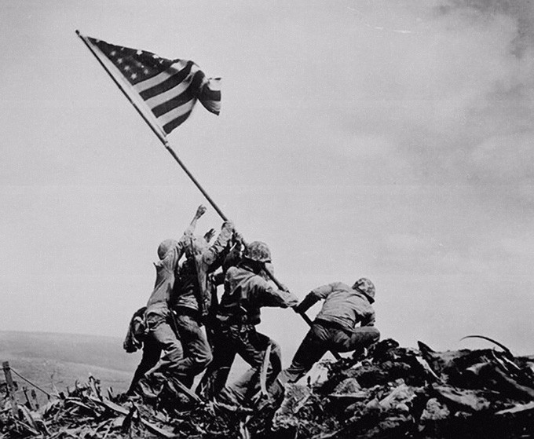

Observation: ____________________________________________
___________________________________________________

Inference: _______________________________________________
___________________________________________________

2. Use the topograph below to answer the following questions:
a. What is the contour of this map? ________
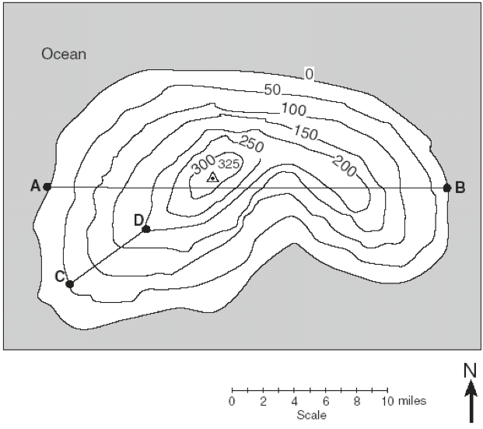

b. What is the highest elevation? __________

c. What is the lowest elevation? ___________

d. What is the elevation at Point A? _______

e. What is the elevation at Point B? _______

f. What is the contour interval of A & B?

g. What is the elevation at Point C? _______

h. What is the elevation at Point D? _______

i. What is the contour interval of C & D?
Appointment #2:

3. Label the following on the world map below
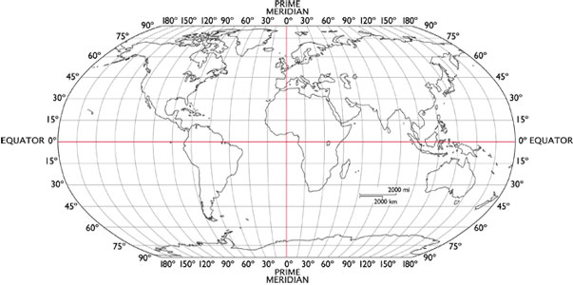
- E. Equator
- PE. Prime Meridian
- TC. Tropic of Cancer
- TCC. Tropic of Capricorn
- B. Beijing: 40°N, 115°E
- NO. New Orleans: 30°N, 90°W
- NY. New York: 40°N, 75°W
- CT. Cape Town: 34°S, 18°E
- H. Hong Kong: 20°N, 115°E

