Name: ______________________________________________ Block: ______ Date: ______________ Unit 3 Guided Review

Group member #1 | Group member #2

1. Fill in the Rock Cycle then write the characteristics of each type of rock in the appropriate box.
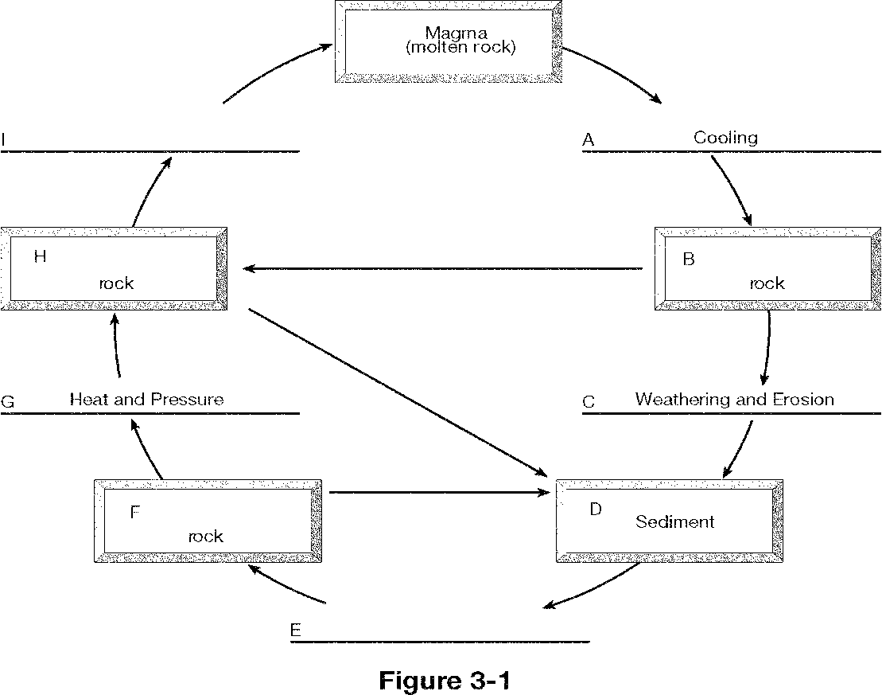
Determine the type of rock for each:
  - Pumice is a light colored rock with so many air bubbles that it can float on water.
  - Granite is a coarse grained rock that is high in density due to its slow cooling formation.
  - Gneiss is a rock with compositional banding (foliation), which is developed from high pressure and heat.
  - Shale is a rock made up of variable amounts of clay minerals and pre-existing rock grains like quartz due to compaction.
  - Chalk is a rock found on the ocean bed and was combined and compressed with microscopic shells and clay minerals.

2. Compare and contrast examples for each of the following:
Chemical Weathering | Physical Weathering | Erosion
What factor dramatically increases their rate?
What type of climate increases their rate?
4. What types of development can help reduce erosion?
3. Answer the following questions using the pyramid on the right.
a. What type of soil contains 60% clay, 30% sand & 10% silt?
b. What type of soil contains 50% clay, 20% sand & 30% silt?
c. If silt loam contains 20% sand & 70% silt, what percentage is clay?
Extension: Why is the soil in North Carolina red?
