Name: ________________________________________ Date: _________________ Unit 4: Review Guide
1. Label and give a brief definition of the terms for the diagram below.
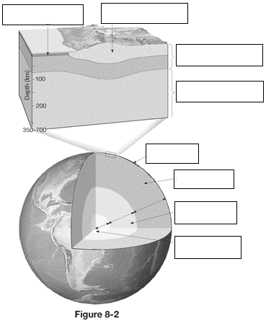

2. Describe how density plays a role in plate tectonics with convection currents.

3. Draw & explain convergent plate boundaries.  a. What types of landforms are created at these boundaries? | 4. Draw & explain divergent plate boundaries.  a. What types of landforms are created at these boundaries?

5. Earthquakes occur at transform plate boundaries. Describe the three different types of faults below.
Draw the fault  Type of EQ Damage | Normal | Reverse | Strike Slip

6. What is the Elastic Rebound Theory?
7. Label the anatomy of an earthquake and list a brief description for each.

8. Name that Wave:
Fastest Wave |  | Slowest Wave
Arrives second at seismograph |  | Least destructive
Most destructive |  | Arrives last at seismograph

9. Draw a picture and annotate the type of movement for each wave.

10. Keep in mind the two most destructive forces from an EQ are: ____________________________ & __________________________

11. If you could create a building or city that was earthquake proof, what would you do? Explain in detail.
12. Label the diagram below:
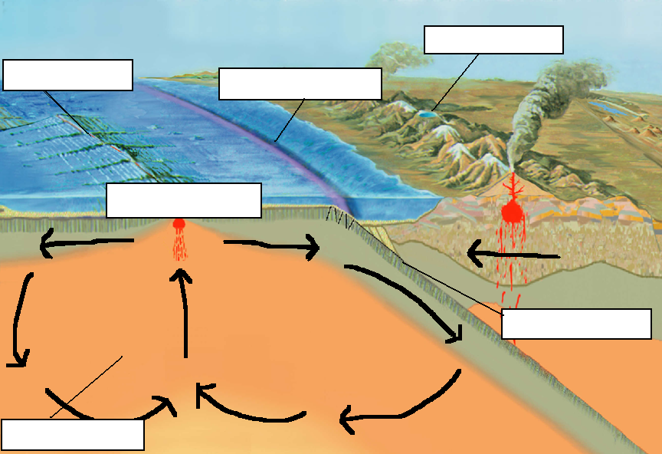

13. Of the three types of volcanoes:
a. Which is the biggest?

b. Which is the broadest?

c. Which is in the ring of fire?

d. Which has a shortest lifetime?

14. What is sea floor spreading?

15. Application: If the seafloor is spreading at a rate of 1.7 cm/year and a section of the seafloor is 1.15 million years old then how far away from the mid ocean ridge is it in cm?

