Name: ______________________________________________ Block: ______ Date: ______________ Unit 4 Guided Review

Group member #1 | Group member #2

1. What are convection currents? What role do they play in plate tectonics?

2. Fill out the following table based on Plate Tectonics:
 | Convergent Boundary | Divergent Boundary | Transform Fault
Draw the type of boundary
Describe the effect on the landform

3. Label the Figure to the right:
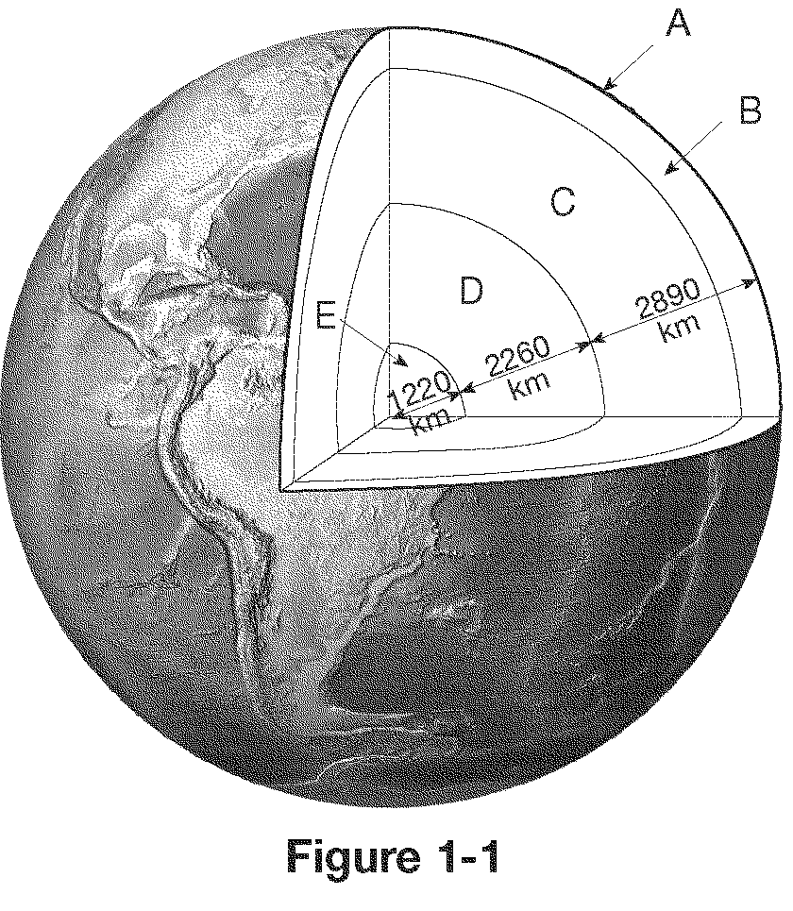

A: _____________________________________

B: _____________________________________

C: _____________________________________

D: _____________________________________

E: _____________________________________

4. Label the diagram below:
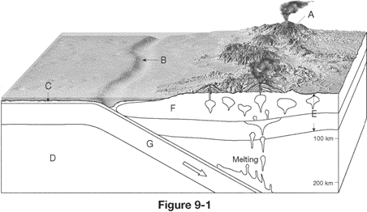
A: _____________________________________

B: _____________________________________

C: _____________________________________

D: _____________________________________

E: _______________________________

F: _________________________________

G: _______________________________

Word Bank: Subduction Zone, Trench, Asthenosphere, Lithosphere, Oceanic Crust, Continental Crust, Volcanic Arc

