Name: _____________________________________________ Due Date: __________________ Homework #4
Unit 7 Review Guide

1. What type of water is the most dense?
2. What is the difference between weather and climate?

A. Cold & fresh
B. Cold & salty
C. Warm & fresh
D. Warm & salty

3. What two main factors are examined to determine an area’s climate?
A. Temperature and precipitation B. Precipitation and soil type
C. Elevation and temperature D. Humidity and proximity to the ocean

4. Which climate zone is closest to the equator of the Kӧppen classification system?
A. Polar B. Tropical C. Temperate D. Tundra

5. Compare & Contrast naturally occurring and human created causes of global warming.

Human Created Causes of Global Warming
Naturally Occurring Causes of Global Warming

6. Sea level is expected to rise because of warmer climate due to the following:
A. Oceans expand as they get warmer B. Glaciers and ice-sheets melt
C. Both of the above D. None of the above
7. Explain the resulting impact of global warming on Earth’s oceans.
10. Label the diagram below:
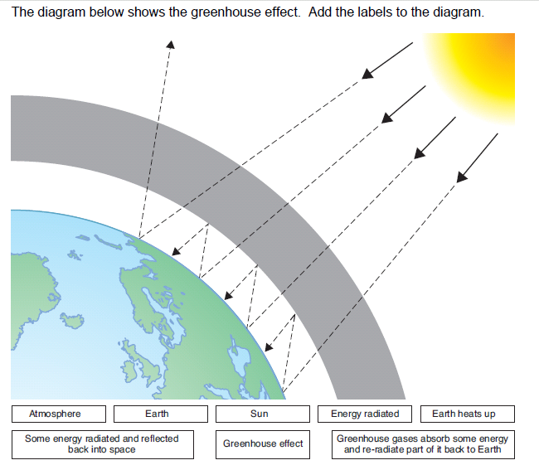

8. What are the 5 greenhouse gases?

9. Which is the most important?

