Name: ____________________________________________ Due Date: ________________ Homework #4

Unit 8 Guided Review

**1. In which layer of the atmosphere, would a person experience the GREATEST air pressure?**

a. Troposphere c. Stratosphere

b. Mesosphere d. Thermosphere

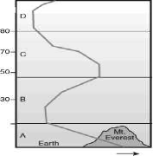

**2. Label the diagram to the right with the appropriate atmospheric layer and the temperature trend in that layer.**

A: _____________________________________

B: _____________________________________

C: _____________________________________

D: _____________________________________

**3. What is the significance of the Ozone layer?**

a. It protects us from the sun’s harmful UV rays

b. It is the layer in which temperature begins to decrease

**5. What is the difference between an air mass and a front?**

c. It is the layer in which weather occurs

d. It protects us from air pollution

**4. Create a Venn Diagram comparing & contrasting Hurricanes & Tornadoes.**

Station 1

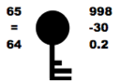

Station 2

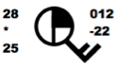

Station 3

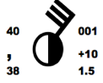

**6. Fill in the table according to the appropriate weather station.**

|  |  |  |  |
| --- | --- | --- | --- |
|  | Station 1 | Station 2 | Station 3 |
| Temperature |  |  |  |
| Dew Point |  |  |  |
| Wind Direction |  |  |  |
| Wind Speed |  |  |  |
| Precipitation |  |  |  |
| Air Pressure |  |  |  |