Name: _________________________________________ Due Date: _____________ Household Water Usage Assignment

Directions: This is a survey to find how much water you use in your home during one full week. Estimate the number of times each day someone in your family does the activity by placing a tally mark in the Times Per Day column. Once you have completed the survey, flip to the back to answer the analysis questions in complete sentences.

Note: washing dishes in a basin is filling up a plastic tub and reusing water to wash and rinse dishes (you do not have running water on the entire time.)
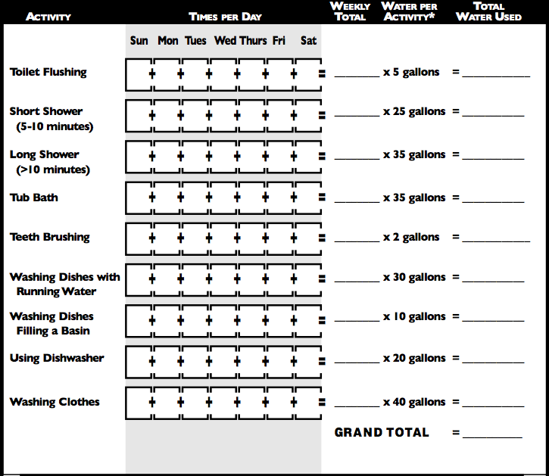

Analysis Questions: Answer in complete sentences for full credit on the assignment.

- Find the average use per person in your family by dividing the grand total by the number of people in your family.

- In your home, which activity happened most often?

  - How much water does this activity require?

- Which activities use the most water each time they occur?

- Besides the activities listed in the survey, what other activities at home consume large amounts of water?

- Describe two (2) ideas to help conserve water in your household.

